Title

SOP for Firefox Installation for Capital first

**Prepared By**

**Helpdesk**

Date: Monday, 02-03- 2019

Version 2.0

**Document History**

|  |  |  |  |
| --- | --- | --- | --- |
| Date | Author | Revision | Description |
| 02-03- 2019 | Team Lead Helpdesk | 1.0 | Document Creation |
| 08-10-2018 | Team Lead Helpdesk | 2.0 | Company Name changed from TBSS to CBSL |

|  |  |  |
| --- | --- | --- |
| Approved By: | Conneqt Business Solutions Limited | |
| Manager-Technology | 2.0 |  |

|  |  |  |  |
| --- | --- | --- | --- |
| **Distribution List** | | | |
| Name | Department | Company | Rights |
| Manager-IT Support | Technology | CBSL | Review & Comment |
| Manager-Technology | Technology | CBSL | Modify |
| AVP Technology | Technology | CBSL | Review & Approve |

Security Classification: CBSLRestricted.

1. Open Firefox Setup 36.0 set up file ”.exe”

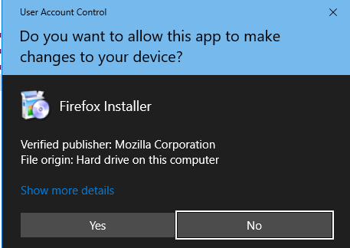

2. Click On “Next” tab

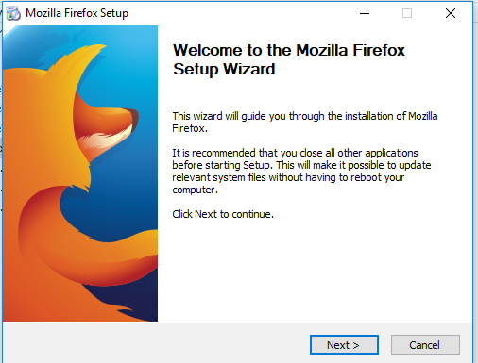

3.

Choose Setup type “Standard”

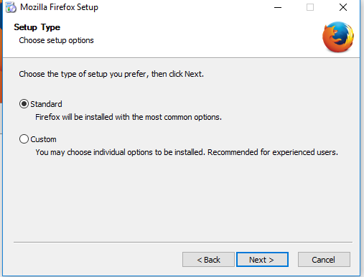

4. Upgarde and finish.

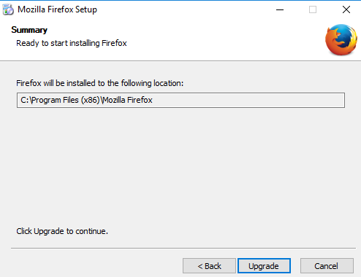

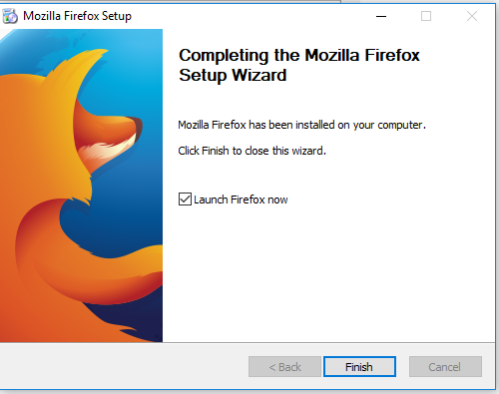

5. After installation complete, following windows show,

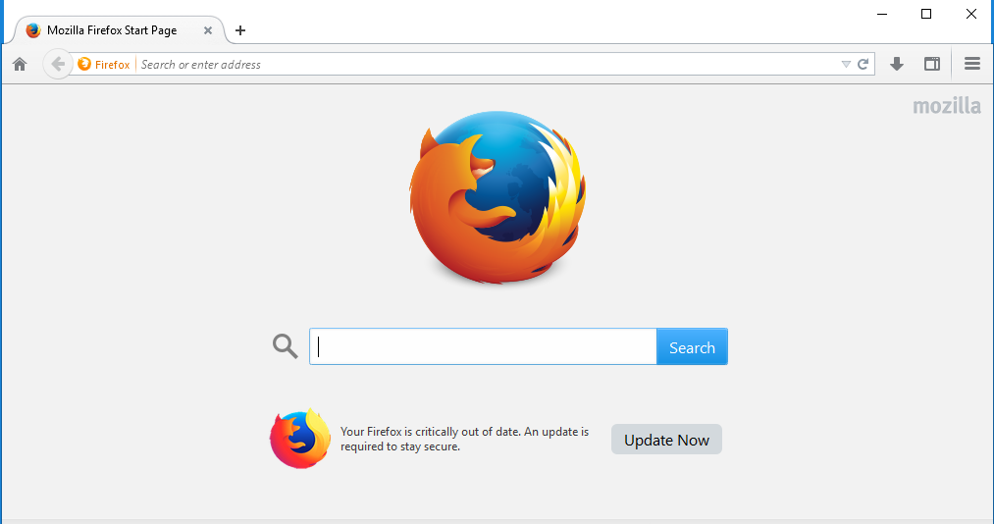

6. Installation complete